1. Write program to find whether a given year is a leap year or not.

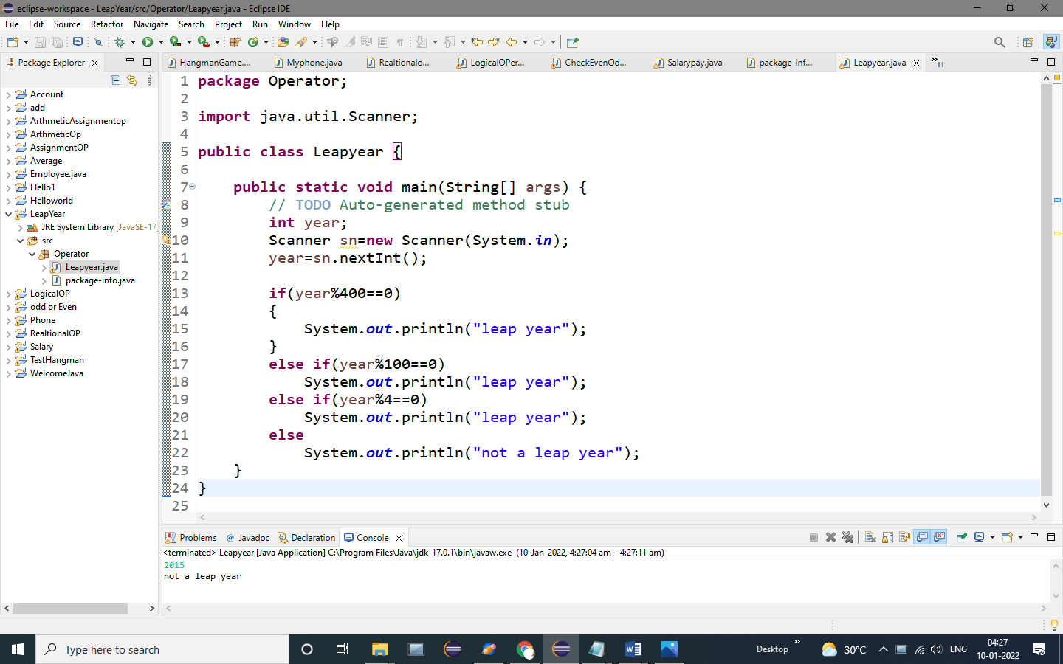

OUTPUT:

2015

Not a leap year

2. Program to check whether a character is an alphabet, digit or special character.

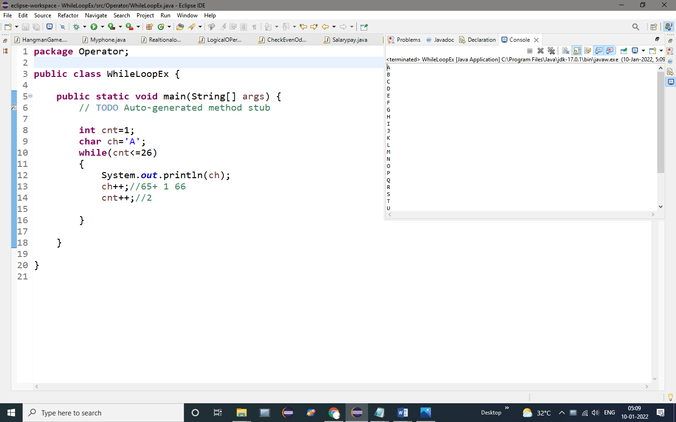

OUTPUT:

A

B

C

D

E

F

G

H

I

J

K

L

M

N

O

P

Q

R

S

T

U

V

W

X

Y